IFT 266 Introduction to Network Information Communication Technology
Lab 16
Port Security Configuration

After you complete each step, put a ‘√’ or ‘x’ in the completed box
- Setup the following topology in packet tracer.
- It is recommended that you use a 2960 switch for this lab.
- You can change the MAC address of the server and PCs by going to the particular Fast Ethernet interface on each device (config tab) and overwrite what is currently listed.
- To check your PC settings run the ipconfig command to verify your connection details
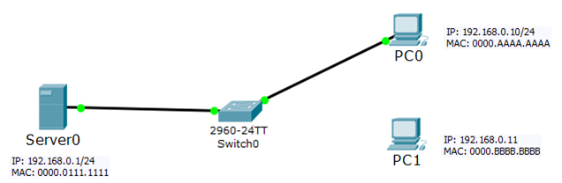



- When we perform a communication through the switch, the switch dynamically collect the MAC address information and stores it in a MAC address table.
- Let us look at the MAC address table on the server before you do any ping communication between the PCs and the server.
- Click on the switch, go to the CLI table and run the command show mac-address-table from enable mode. The MAC address table should be empty

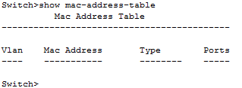

- Now we will perform a ping from PC0 to the Server.

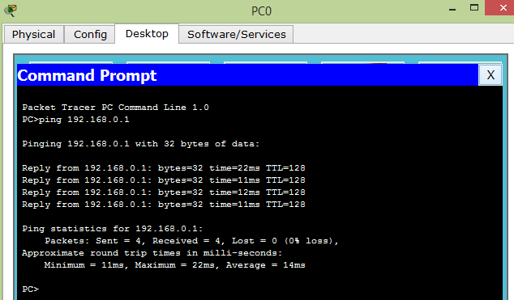

- Now go back to the switch and re-run the show mac address table command. There are now some entries in the MAC address table. My switch learned dynamically that Fa0/1 is connected to the MAC address 0000.0111.1111 on the server and 0000.AAAA.AAAA on the PCs Fa0/2 port.

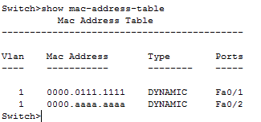

When that inappropriate device attempts to send frames to the switch interface, the switch can take different actions, ranging from simply issuing informational messages to effectively shutting down the interface.

Port security is used to cause the switch to discard some frames sent into and out of an interface.

Port security has three basic features with which it determines which frames to filter:
- Limit which specific MAC addresses can send and receive frames on a switch interface, discarding frames to/from other MAC addresses
- Limit the number of MAC addresses using the interface, discarding frames to/from MAC addresses learned after the maximum limit is reached
- A combination of the previous two points

Switches enable port security per port, with different settings available per port.

Each port has a maximum number of allowed MAC addresses

For all frames entering that port, only that number of different source MAC addresses can be used in different incoming frames before port security thinks a violation has occurred.

When a frame with a new source MAC address arrives, pushing the number of MAC addresses past the allowed maximum, a port security violation occurs.

At that point, the switch takes action—by default, discarding all future incoming traffic on that port

- Sometimes you just want this specific PC0 to communicate through this port (Fa0/2) on the switch. You do not want an employee to connect their own laptop to the network. One way to protect the network against this type of problem we can set it on the switch to set a port to a particular MAC address i.e. apply port security.
You specify the port (fa0/2) that we want to apply the port security, then we specify that the connection is mode access (switch to host connection) and then we enable switchport port-security on the interface.
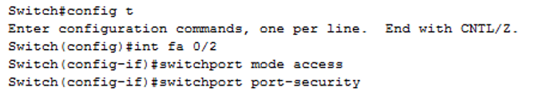

- Now we will set the port security on the interface.
I can set the maximum mac address accept by the port. We will set the maximum to 1 (only allow one MAC address through this interface)
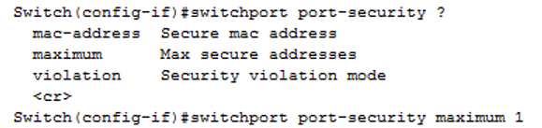

- Now I can with statically assign any MAC address or use they key word ‘sticky’ which dynamically assign the port address of current connect PC to the AC address table for the port security. Use sticky when the network is in a stable mode because assigning the static MAC address for each device in a network is time consuming.

- Nearly done with the configuration for port security. Let’s look at the violation mode. You have different violation modes i.e. protect, restrict and shutdown. Shutdown is default on Cisco devices. They put the interface into error disable mode (shutdown) when the maximum number of secure MAC addresses exceeds its limit. Restrict and protect (drop the packets when max number of secure MAC addresses exceeds the limit) are less used.
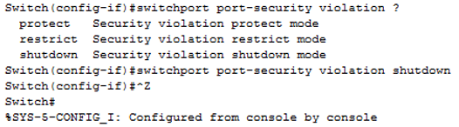

- Do you understand the difference between the different violation modes i.e. protect, restrict and shutdown. You may to do some extra research on this point.

- We will now show port security status. MAC security address is 1 on Fa0/2, current address count is zero as is the security violation.
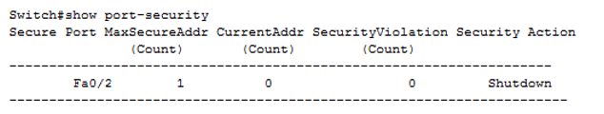

- Now use the show run and see how it works. Look down and see switchport mode as access, port security is turned on and using sticky as port-security MAC address.

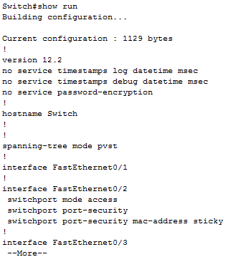

- Do the same ping again, ping PC0 → Sever and see how port security works. After the ping, re-run the show run command and this time the switch learned the sticky MAC address. Assign the PC MAC address to our port.

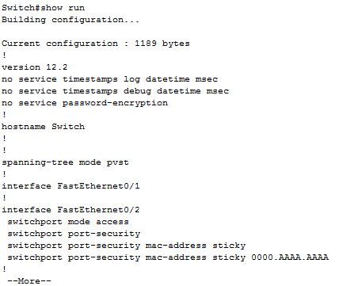

- Use the show port-security command, you can see the Current Address is now increased to 1. The security action is shutdown by default.

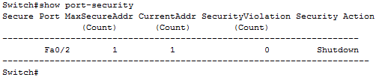

- Now we will disconnect the cable from PC0 and connect to PC1 which has a different MAC address i.e. 0000.BBBB.BBBB.

- When I now ping from PC1, the switch will detect the new MAC address that is not setup on the interface, it will shutdown the port immediately as shown
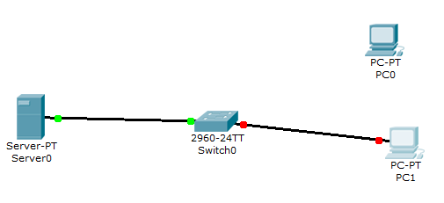

- Run the show i pint brief which will show the interface as ‘down’
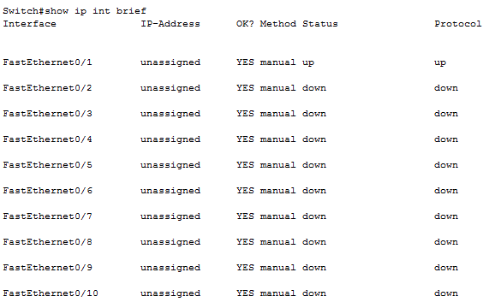

- Run the show interfaces fa 0/2 you can see on the first line its says ‘err-disabled’

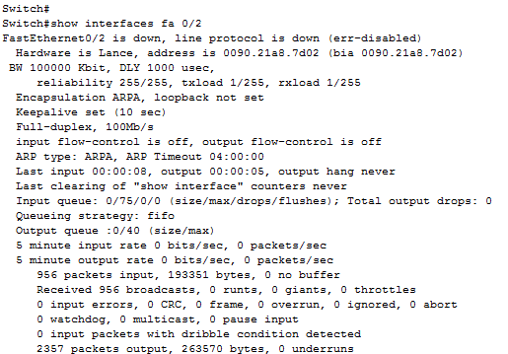

- Run the show port-security command and now the Security Violation is count to 1 i.e. violation occurred and interface is shutdown.

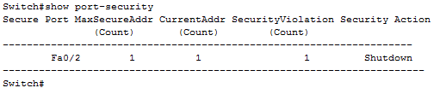

- Now bring back the interface, connect back to original PC. The port is not automatically coming up.

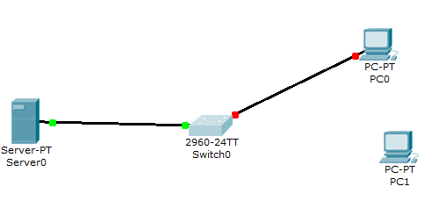

- Go to the switch, go into CLI mode and then back into the interface fa 0/2. Issue the command ‘shutdown’ which will turn back on the port and then issue the command ‘no shut’ which turns on the interface.
- Now run the command show ip int brief and see that the link has come back up

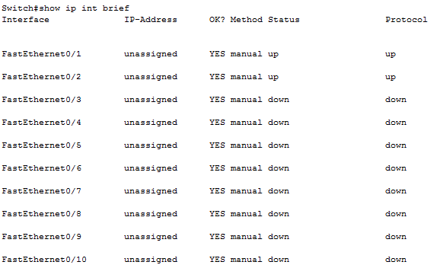

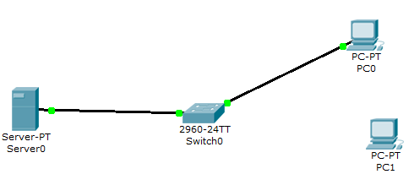

- Port security can be basic and helpful but user can use MAC spoofing, change the other PCs MAC address.

